**­­­**

Class 7

**Lecture 14**

**HTML**

**HTML Basic**

**HTML**



**Lab Objectives:**

* HTML Structure.
* HTML Editor.
* Text Formatting.

**HTML Structure**

An HTML document has two main parts.

* Head- The head element contains title and meta data of a web document.
* Body- The body element contains the information that you want to display on a web page.

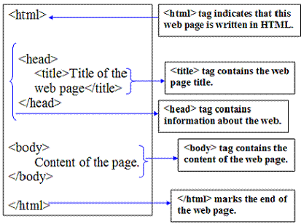

**HTML Editor**

Write HTML Using Notepad or TextEdit Web pages can be created and modified by using professional HTML editors. However, for learning HTML we recommend a simple text editor like Notepad (PC) or TextEdit (Mac). We believe using a simple text editor is a good way to learn HTML. Follow the four steps below to create your first web page with Notepad or TextEdit.

**Creating our first web page using html**

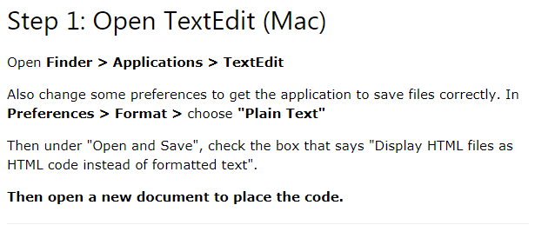

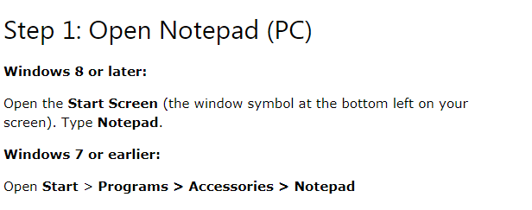

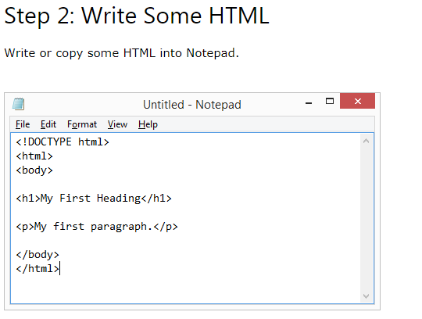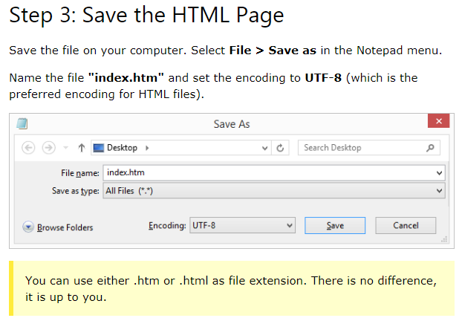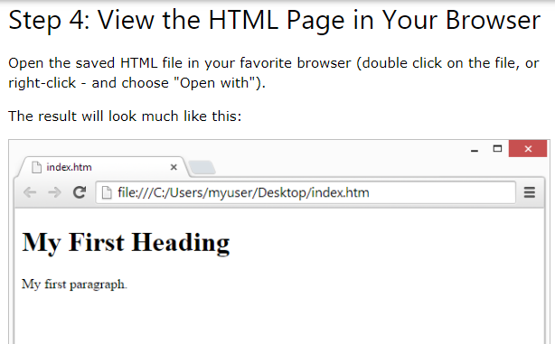

**HTML Elements**

An HTML element usually consists of a start tag and end tag, with the content inserted in between:

<tagname>Content goes here...</tagname>

The HTML element is everything from the start tag to the end tag:

<p>My first paragraph.</p>

